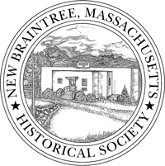
PRESERVATION – CONSERVATION – EDUCATION
The New Braintree Historical Society
P.O. Box 112
New Braintree, MA 01531

Become a Member of the New Braintree Historical Society!
***
We are a private, not for profit organization committed to preserving and conserving historical materials related to New Braintree. Our fundamental purpose is to stimulate local pride in and knowledge of our town’s history. Through events and programs the Society looks back to the past and relates it to the present and the future. None of this would be possible without the dedicated help of our members. Meetings are held at 7 p.m. on the second Thursday of the month at the 1939 Grade School/Museum in the town center.
***

Join Us.
---------------------------------------------------------------------------------------------

Name ___________________________________________________________
Address _____________________________________Phone _______________
City ___________________________________State _______Zip ___________
Memberships □ Individual $15 □ Family $20 (yearly) □Lifetime $100
Make checks payable to: New Braintree Historical Society
Email address: newbraintreehistoricalsociety.org

THANK YOU

